|  |
| --- |
| Extended Kalman Filtering of State and Parametric Bias Estimation of a Li-Ion Battery Model |
| MAE 298 – Estimation Theory Final Project |
| Felipe Valdez  Jonathan Dorsey |

|  |
| --- |
| Abstract |
| *The increasing demand for electric vehicles (EVs) has led to technological advancements in the field of battery technology. State of charge (SOC) estimation is a vital function of the battery management system - the heart of electric vehicles, and Kalman filtering is a common method for SOC estimation. Due to the non-uniformities in tuning and testing scenarios, quantifying performance of SOC estimation algorithms is difficult. In this work, an SOC estimation algorithm is developed, Extended Kalman Filter (EKF), and tested for a variety of scenarios like adding sensor noise and bias to terminal voltage and current, and varying state and parameter initializations. A comparison between*  *a deterministic estimation technique using Youla paramertization and the well-established stochastic estimation technique, Extended Kalman filtering, is performed and analyzed for robust performance?* |

Table of Contents

**1. Introduction & Literature Review** **2**

1.1 Motivation 2

1.2 Related Work3

1.2.1 Battery Modeling3

1.2.2 Estimation of Algorithms3

1.3 Objectives3

**2. System Modeling & Analysis 4**

2.1 Overview of Li-Ion Battery5

2.1.1 State of Charge5

2.1.2 Open Circuit Voltage5

2.2 Electrical Equivalent Circuit Model5

2.1.1 Continuous Time Model5

2.1.2 Discrete Time Model5

2.3 Sensor Bias Modeling5

2.3.1 Current Sensor Bias5

2.3.2 Voltage Sensor Bias5

2.3.3 Observability Analysis5

**3. Algorithms & Implementation 4**

3.1 Linear Kalman Filter5

3.2 Extended Kalman Filter5

3.3 State & Parametric Estimation5

3.3.1 Dual EKF Estimation5

**4. Results & Discussion 4**

4.1 The Setup5

4.1.1 Simulation Setup5

4.1.2 Performance Indices5

4.2 Simulation Results5

4.2.1 State KF vs EKF5

4.2.2 State EKF vs Dual EKF 5

4.2.3 Sensor Bias Estimation5

4.2.3 State EKF vs State Youla Estimation5

**5. Future Work4**

# 1. Introduction & Literature Review

Introduce your project and briefly review the sources you used for this paper. This is expected to be 1-2 papers at most. Cite references in the text using IEEE style [1].

## Motivation

## Related Work

## Battery Modeling

## Estimation Algorithms

## Objectives

# 2. System Modeling & Analysis

## Overview of Li-Ion Battery

In any modeling methodology, the first step is to understand the actually physics, mechanisms and governing equations (if available). The focus of this paper being the estimation of Lithium Ion battery, it makes sense to first understand the basic fundamental quantities of interest associated with batteries in general and Li-Ion batteries specifically.

When it comes to Li-Ion batteries, there are predominately two quantities which are of interest to researchs. These are the “State of Charge” and the “State of Health” of the battery. While both are being heavily researched, the State of Charge of a system or SOC, is the predominate quantity

## State of Charge

As mentioned above, one of the most important parameters of a battery is the State of Charge or SOC. The SOC of a battery effectively provides a measure of the batteries actually capacity available to the device or end user. This is an important parameter to know since the safety of many batteries, such as the Li-Ion batteries used in this paper, have the potential to be extremely dangerous and even explode or cause fires.

Unfortunately, the SOC of a battery is not a directly measurable quantity and therefore must be estimated in order to make available for application in control of battery management systems. In order to overcome the drawback, this papers presents the Extended Kalman Filter as the estimation technique of choice to reliably and accurately predict the SOC of the battery of interest.

## Open Circuit Voltage

One of the key modeling tools which is employed in this paper is the relationship between the SOC and the Open Circuit Voltage (OCV) of a battery. It has been experimentally shown that is for Li-Ion batteries, the OCV, can be computed as a function of the batteries SOC. While determining the relationship between these two quantities requires very precise and well executed experimental measurements.

For the purposes of this paper, the experimental relationship between these two quantities are assumed to be given. However, even given this data, the OCV/SOC relationship is typically nonlinear and normally requires either linearization-based estimation schemes (such as Kalman Filter) or nonlinear approximation such as (Extended Kalman Filter).

## Electrical Equivalent Circuit Model

Regardless of the techniques used to estimate the SOC, the OCV is a critical quantity in that it allows researchers to model batteries in terms of electrical circuits, and appl

One of the predominate issues with controlling or estimating battery parameters from first principle models is the required complexity of the fundamental dynamics and mechanisms of a battery. For example, the first principle model of a Li-Ion battery is modeled using partial differential equations (PDEs). Needless to say, the complexity of PDE models are far from practically applicable straight from derivation and often require extensive computational resources to solve numerically.

To bypass this problem, it is desired to use simplified low order dynamic models that are numerically tractable for the intended application. This leads to the use of “Equivalent Circuit Models,” or EMCs. The benefit of EMCs is their inherent ease of derivation and application which becomes apparent in commercial uses where computing overhead is extremely limited, for cost considerations.

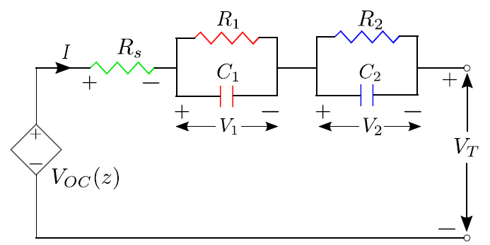

(soc)

This paper will use the “Dual Polarity” equivalent circuit model as it is not only one of the most popular LI-Ion battery models in commercial use today but also the relative ease of reframing the model into an Extended Kalman Filter (EKF).

The circuit schematic for the DP model is shown above. Notice that the terminal voltage of the battery (U_L) is easily shown to be related to the dynamics of the open circuit voltage (U_oc), the series resistance (R0) and the two resistor-capacitor circuits. By application of basic circuit rules (KCL and KVL), the dynamics of the system can easily be derived with only

## Continuous Time Model

As mentioned previously, by using standard circuit analysis, we can extract the dynamic behavior of the system.

By applying KVL around the complete loop of the circuit, we get the following expression for the terminal voltage of the circuit as a function of the internal elements of the circuits.

By applying KCL to both RC branches we derive the following equations…

By including the expression for SOC with the equations defined above, the continuous time state space model can be written as…

## Discrete Time Model

## Sensor Bias Modeling

## Current Sensor Bias

## Voltage Sensor Bias

## Observability Analysis

# 3. Algorithms & Implementation

## Linear Kalman Filter

## Extended Kalman Filter

## State & Parametric Estimation

## Dual EKF

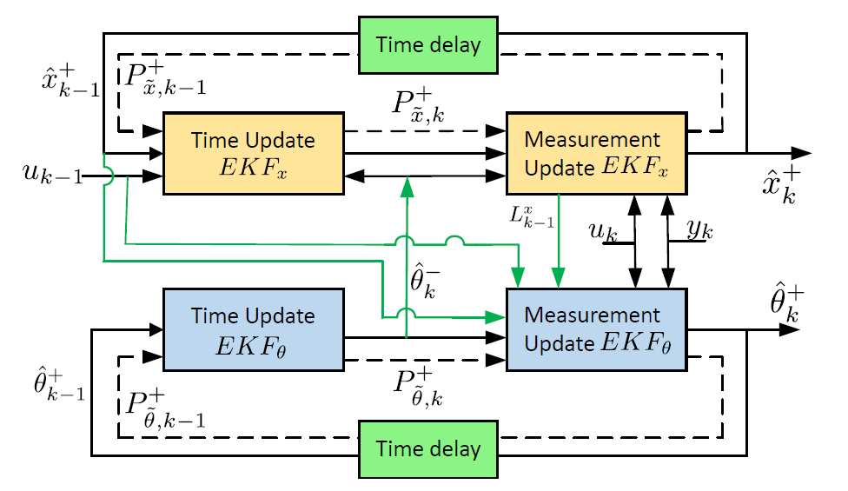

# 4. Results & Discussion

## The Setup

## Simulation Setup

The overall simulation setup consists of the estimation algorithms KF, EKF and DEKF used with the battery model explained previously. For this study, MATLAB is used to simulate the measurements required for the Kalman algorithms….

A typical BMS is equipped with current, voltage and temperature sensors which have limited accuracy due to intrinsic measurement noise and bias. In this work, we only considered current and voltage measurement bias. To test estimation algorithms under different sensor properties, noise and bias are added to both current as well as terminal voltage signals. The noise added is Gaussian with zero-mean and a standard deviation of 1% of the corresponding signal’s maximum value. The noise standard-deviation is allowed to increase up to 2% to simulate effects like aging, stress and electromagnetic interference. The bias level is set as 2:5% of the corresponding signal’s maximum value. Bias level is stepped up from 0% to 2.5% and then 2.5% to 5%.

## Performance Indices

Root mean square error: RMSE is the square root of mean of square of all errors. It

is calculated using the actual and estimated values, and is computed for SOC as well

as terminal voltage. It denotes the estimation accuracy.

Infinity Norm of SOC Error: It gives the worse-case measure of the SOC error and is

given by where n = 600 and N is the length of the drive cycle.

Since the sampling time is 1s, this corresponding to ignoring the first 10min of data.

Variance of SOC Error: It refers to the average variance of SOC error over whole simulation

time (first 600 samples are excluded). Variance measures the estimate’s uncertainty

and is denoted by . With every new measurement, the Kalman filter aims to reduce uncertainty and hence, the variance ideally decreases and remains constant at steady-state.

## Simulation Results

## Model Validation

A model validation was conducted to verify the derived 2nd Order Equivalent Circuit Model (ECM). This verification was performed by generating data of actual SOC and terminal voltage (with process noise) from a “true” model of a 3rd Order ECM given time and battery current data as inputs. The simulated “true” data was then used on a derived 3rd order circuit battery model with an EKF implementation for validation. The results are shown below.

1. b.

 

c. d.

 

**Figure X**. blah blah blah

After concluding that the derived 3rd order ECM’s SOC closely matched the “true” SOC data, a 2nd order ECM was derived and used as a framework to design an Extended Kalman Filter and Dual EKF to estimate the SOC and Voltage/Current Bias as it will be explained in the next sections.

## State KF vs EKF

A linear Kalman Filter and Extended Kalman Filter was implemented on a nonlinear equivalent circuit battery model to estimate the its state of charge. Using the nonlinear data on a Linear KF gives inaccurate results and it can be seen that EKF performs a lot better. This is due to the fact that Linear KF does not consider nonlinearities of the system form the open circuit voltage dependence on SOC. On the other hand, EKF considers the nonlinearities of the battery model by linearization using first order Taylor series about an operating point, this in turn significantly improves the SOC estimation as shown below.

 

## State EKF vs Dual EKF

The performance of State and Dual EKF in estimating SOC was compared. A terminal voltage bias was added to the “true” model and its “true” data was used by the EKF and DEKF algorithms. It can be noticed that DEKF performs better in estimating SOC when compared to EKF in the presence of voltage bias.

 



Table 1 – State EKF vs DEKF

|  |  |  |
| --- | --- | --- |
| **Index** | **State EKF** | **Dual EKF** |
|  | 0.7605 | 0.7421 |
|  | 1.0005 | 1.0003 |
|  | 3.8643 | 3.8643 |
|  | 8.13x10-6 | 8.34x10-6 |

## EKF Parameter Variation

## Sensor Bias Estimation

## State EKF vs Youla Estimation

NOTES:

**Model Validation**

**RMS Error**

**Parameter Estimation using Dual EKF**

**Covariance Agreement (Model vs Truth)**

**Biased Vs Unbiased Simulations**

**Robustness**

* Sensor noise
* Parameter Variation

**EKF vs KF Comparison**

## Figures

Figures should be centered on the page. Every figure should be numbered, have a caption, and be cited in the text. For example, see Figure 1. If you have many figures, you may find it useful to use Word’s Cross-Reference feature to keep track of figure, table, and equation numbering.

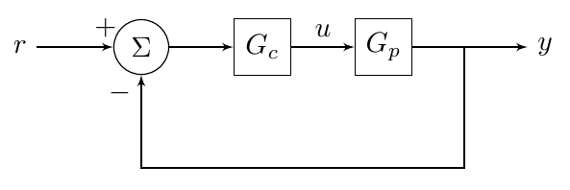

Figure 1 - A simple block diagram as an example of how to structure a figure.

## Tables

Tables of data should be treated like figures: centered, captioned, and cited in the text. For example, see Table 1.

Table 1 - This is a caption.

|  |  |  |
| --- | --- | --- |
| Column 1 Title | Column 2 Title | Column 3 Title |
| 1 | 5 | 9 |
| 2 | 6 | 10 |
| 3 | 7 | 11 |
| 4 | 8 | 12 |

## Equations

Equations should be on their own line and centered. Be sure to define all terms used in the equation. For example,

where is force, is mass, and is acceleration.

# Future Work

Briefly summarize your project and its findings. Discuss any open questions or potential avenues for further research.

UKF, PF, Adaptive EKF, Gain Scheduled EKF, MHE.

# References

Use IEEE format for your references. It is useful but not necessary to use Word’s built in features for references and bibliographies.

|  |  |
| --- | --- |
| [1] | IEEE Periodicals, "IEEE Reference Guide," IEEE, Piscataway, NJ, 2018. |

# Supplemental Material

Include all Matlab code (Matlab has a “publish” feature that will help format your code nicely for Word). If you have Simulink models, include pictures of the models and code for any user-defined functions. If applicable, include additional figures and any other important work that you did not include in the body.

## Matlab Code

### File 1

(code here)

### File 2

(code here)

## Simulink Models

### Model 1

(image here)

(code for user-defined functions here)

## Additional Figures

## Anything Else